Activity No. 05

Aim: How to Connect three PCs in a LAN using a switch and Ethernet Cables.
Theory:
Connect the first computer to the Internet via an Ethernet cable. Connect the other two computers to the first computer using Ethernet cables and an Ethernet switch. The switch allows multiple computers to connect to each other and share the Internet connection.
The simplest method to connect three computer systems without using the internet is through an ethernet cable. Once the connection is established the three systems can share files between them and also view and edit those files. In this tutorial, we will learn to step by step to establish a connection between three computers using an ethernet cable.
Procedure:
Follow the steps below to connect three computers using an ethernet cable:
Step 1: First check if the three selected systems support Ethernet cable.
Step 2: If either or three systems does not support ethernet cable then an external ethernet adapter is required.
Step 3: Plug one end of the ethernet cable in the first system and the remaining end in the all system.
Step 4: Once the ethernet cables are plugged in both the systems, open Control Panel. Press the start button and type control panel or press “ + R” and type “control panel” and press enter.
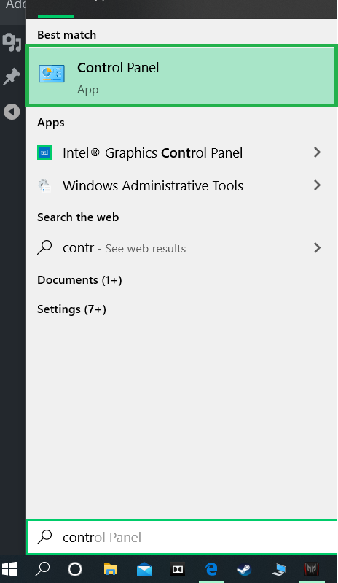
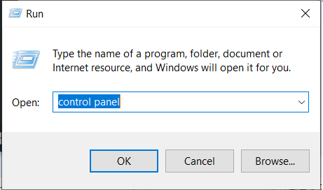
Step 5: In the control panel select the “Nethreerk and Internet” option.
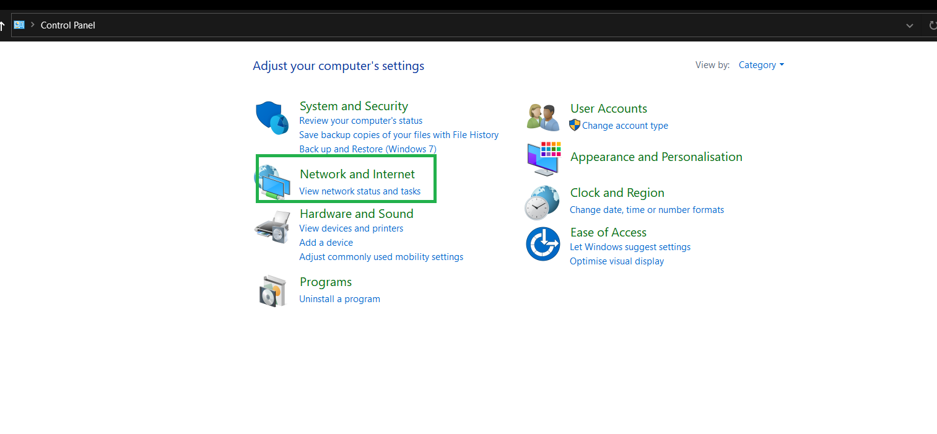
Step 6: Then select “Nethreerk sharing center“.
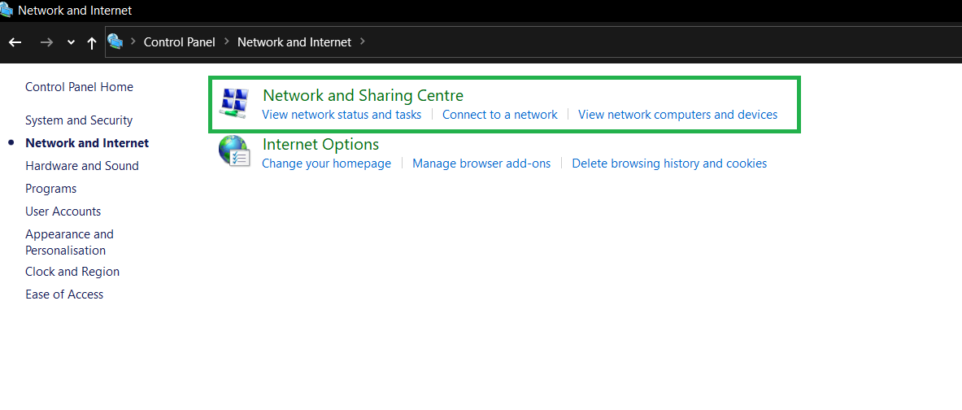
Step 7: From upper left portion of screen select “change advanced sharing settings“.
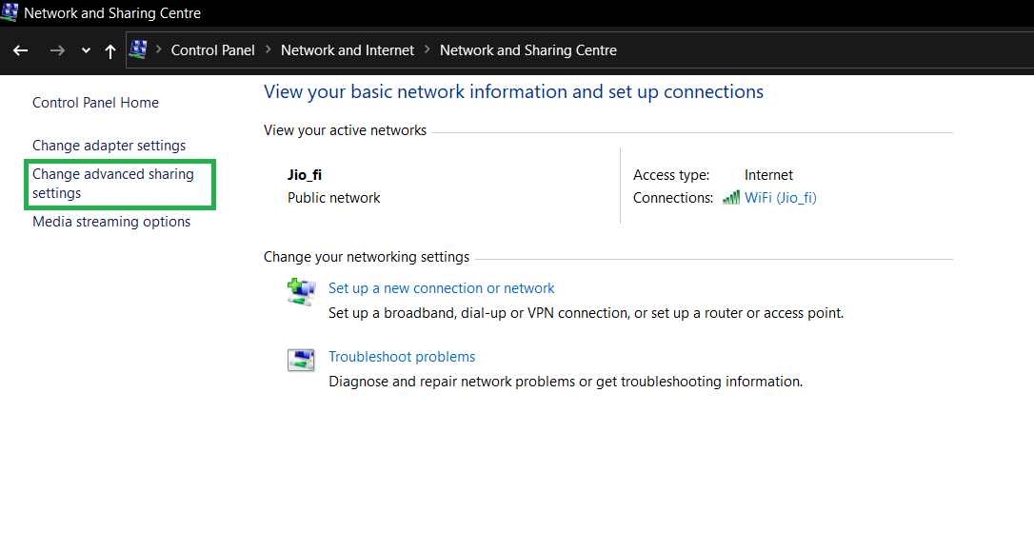
Step 8: Under “File and printer sharing” select “Turn on file and printer sharing” option.
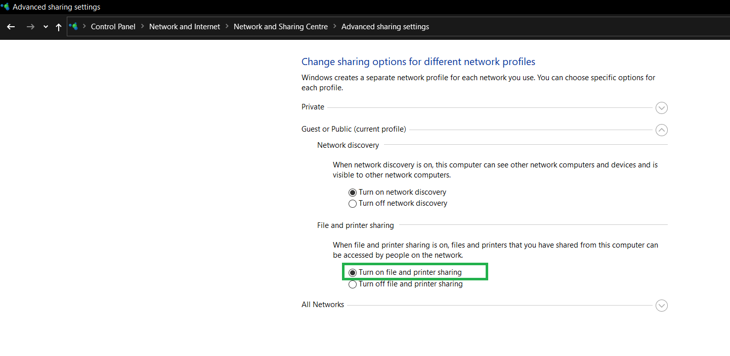
Step 9: Then click on “Save Changes“.

Step 10: To allow the three connected systems to view or edit shared data, a folder first needs to be selected and then click on the share tab then select the recipients then click on done.
Step 11: Now on the second system open file explorer, select the system who is sharing the file, enter the password if password protected.
Step 12: View the contents of the shared folder or edit them.

